AWS Simple Storage Service (Amazon S3)
Introduction
Amazon Simple Storage Service (Amazon S3) is an AWS object storage service used to store and retrieve large amounts of data from anywhere over the internet.
S3 is commonly used for storing:
- Images
- Videos
- Documents
- Application files
- Backups
- Logs
- Static website files
- Data analytics datasets
S3 provides high durability, scalability, security, and multiple storage classes that help reduce storage costs.
S3 Basic Architecture
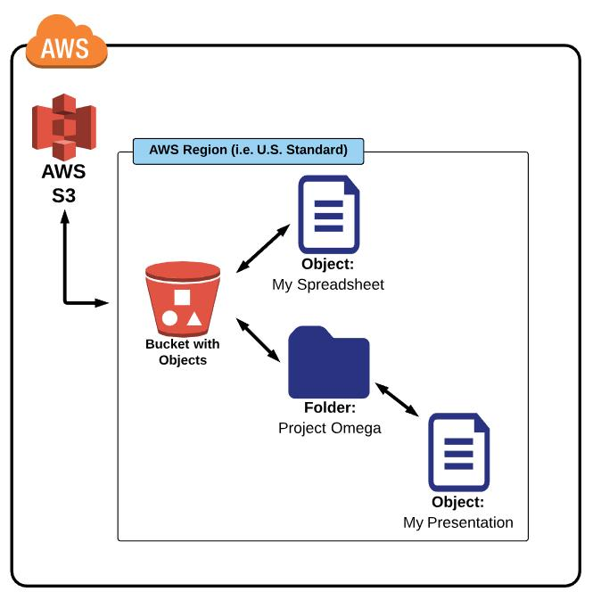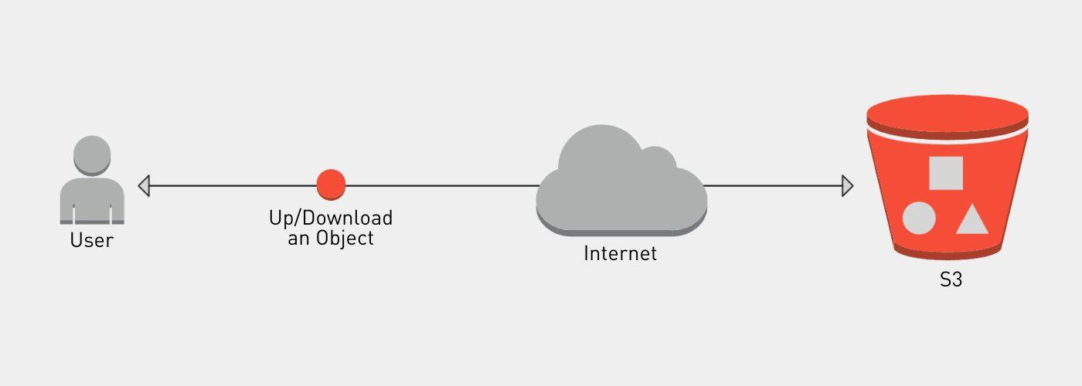

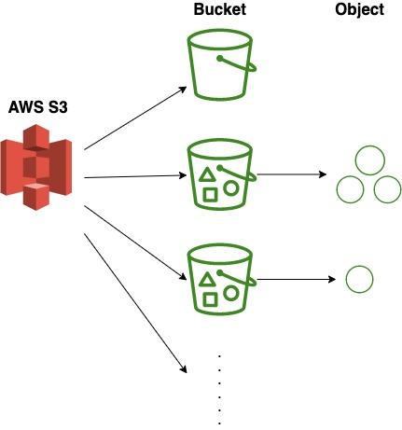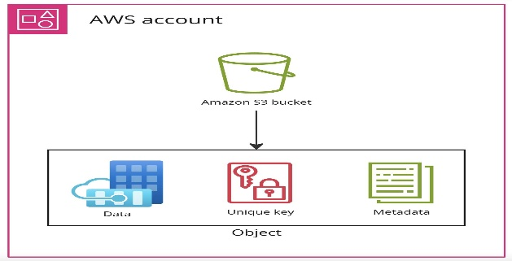

Bucket
A bucket is a logical container used to store objects.
A container for objects with the following characteristics:
- Global Namespace: Bucket names must be unique across all AWS accounts worldwide (like a DNS name).
- Region Specific: You create a bucket in a specific region (e.g., ap-southeast-1), and your data never leaves that region unless you explicitly move it.
Object
An object is the actual data stored in S3.
An object contains:
- Key
- Data
- Metadata

S3 Storage Classes
S3 provides different storage classes based on how frequently data is accessed.
Storage Class | Suitable For
S3 Standard | Frequently accessed data
S3 Intelligent-Tiering | Data with changing or unpredictable access patterns
S3 Standard-IA | Infrequently accessed data
S3 One Zone-IA | Infrequently accessed, non-critical data
S3 Glacier Instant Retrieval | Archive data requiring rapid access
S3 Glacier Flexible Retrieval | Long-term archive data
S3 Glacier Deep Archive | Very long-term archive data

Creating an S3 Bucket
Step 1: Login to AWS
- Open the Amazon Web Services Management Console.
- Sign in using your AWS account.
- In the search bar, type S3.
- Select S3 – Scalable Storage in the Cloud.

Step 2: Open S3
- Open S3 Dashboard.
- Click Create bucket.
Step 3: Enter Bucket Name
Under General configuration:
- Enter a unique Bucket name.
- Example: s3-bucket
Bucket names must be globally unique across AWS.
Example: s3-bucket
Step 4: Choose AWS Region
Select the AWS Region where you want your bucket.
Step 5: Block Public Access
For a normal learning bucket:
- Keep Block all public access enabled.
- This keeps your bucket and objects private by default.
- Click the confirmation checkbox if required.
Step 6: Bucket Versioning
Under Bucket Versioning:
- Enable → if you want to maintain multiple versions of objects.
- Disable → for a basic learning bucket.
For your first bucket, you can keep it disabled.
Step 7: Default Encryption
- Keep the default encryption option enabled.
- This encrypts objects stored in the bucket.
Server-Side Encryption (SSE): S3 encrypts your data at rest.
- SSE-S3: Keys managed by S3 (Default).
- SSE-KMS: Keys managed by AWS KMS (Provides audit trail and rotation).
- SSE-C: Keys managed by the customer.

Step 8: Create the Bucket
Then click: Create bucket
S3 bucket is now created.
Step 9: Open Your Bucket
Click the bucket name.
There are tabs/options such as:
- Objects
- Properties
- Permissions
- Metrics
- Management
Step 11: Upload a File
Inside your bucket:
- Click Upload.
- Click Add files.
- Select a file from your computer.
- Click Upload.
For example: s3-bucket.docx
After uploading, the file will appear under the Objects section.
Use Cases
Amazon S3 is widely used across cloud applications because of its scalability, durability, security, and cost-effective storage options.
- Data Storage
- Backup and Recovery
- Static Website Hosting
- Data Archiving
- Big Data Analytics
- Application Hosting

